WEEK 1 🡪 Basic Concepts and axioms, sets, counting

WEEK 2 🡪 Permutation and combination

WEEK 3 🡪 Probability

WEEK 4 🡪 Conditional probability, independence \*\*\*IMPORTANT

QUIZ (15%)

WEEK 5 🡪 Random variables

WEEK 6 🡪 Continuous and discrete random variables

WEEK 7 🡪 Probability distribution functions of random variables

WEEK 8 🡪 Probability density functions of random variables

MIDTERM (30%)

WEEK 9 🡪 Gauss, Binomial distribution

WEEK 10 🡪 Binomial, Poisson distributions

WEEK 11 🡪Geometric and negative binomial distributions

QUIZ 2 (15%)

WEEK 12 🡪 Expected value

WEEK 13 🡪 Expected values of random variables

WEEK 14 🡪 Central Limit Theorem

WEEK 15 🡪 Correlation and Regression

WEEK 16 🡪 FINAL EXAM (40%)

What is Probability?

First thing we usually remember is the following example:

Suppose a “fair” coin is tossed

The probability of getting TAIL is ½.

More formally,

Sample space (All the possible outcomes): {H, T}

Event: Getting T, outcome is {T}

Probability of the event:

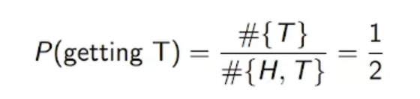

Misconception: Yanılgı. Means intuitively. We read question and say this should be ½. Answer may be far away from ½.

Probability has reference partly to our ignorance, partly to our knowledge…

The theory of chances consists in reducing all events of the same kind to a certain number of cases equally possible, that is, such that we are equally undecided as to their existence; and determining the number of these cases which are favourable to the event sought. The ratio of that number to the number of all the possible cases is the measure of probability…

LAPLACE

Havanın durumunu, atış hızını vs. bilsen aslında yazı mı tura mı geleceğini bilirsin. Probability bildiğimiz şeylerle bilmediklerimizi ne kadar birleştirebildiğimizle alakalı.

Brief History of Probability

Cordano (1500s)

* Italian mathematicians but gambler

Pascal and Fermat (1600s)

* They send letters each other, discuss problems probability related
* It started with question of gambler

Jacob Bernoulli and Laplace (1700s)

* They send letters each other, discuss problems probability related

Bayes (1763)

Kolmogorov

* The modern axiomatic theory of Probability (1933)
* First one to sit and axiomatics of probability and mathematical background of it
* Then probability became a science

Axioms of Probability

Let S be a sample space (collection of all possible outcomes),

* Axiom 1: P(E) >= 0 for all events E S
  + P(E) means probability of event E
  + Probabilistic measure is between 0 and 1
* Axiom 2: P(S) = 1
  + Probability of getting an outcome in a sample space is 1
* Axiom 3: Any countable sequence of disjoint sets (mutually exclusive events) E1, E2, … satisfies

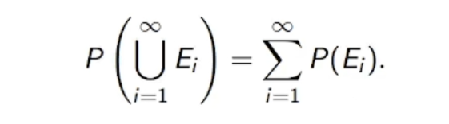

For 2 separate events (throw a coin then roll a dice):

P(E1 U E2) = P(E1) + P(E2)

Why do we need probability?

Probability is a formal tool to deal with random variables

* In math, when we have variables, you define what changes
* If sth is changing with probabilistic nature (you cant know when), then it is random variable

Scientists, engineers deal with random variables often

* Because this is world of uncertanities
* We don’t know when the earthquake happen or what is the weather like tomorrow exactly

In computer science, we deal with random data a lot!

We want to make “smart” guesses

Some applications

Some of them overlap:

* Forecasting (Weather etc.)
* Actuarial Sciences (Insurance etc.)
* Quality Control
* Stochastic
* Statistics
* Data interpretation, machine learning, AI etc.
* Only the applications of conditional probability is hard to list
* many more…

Regression: A way to “predict” future

Curve fitting:

* Curve fitting is expressing a discrete set of data points as a continuous function.
* It is frequently used in engineering. For example the empirical relations that engineers use in heat transfer and fluid mechanics are functions fitted to experimental data
* Basically we try to explore how the independent variable effects the dependent variable.

Regression: Tamamen olasılık ve istatistik

Interpolation: Matematiksel, deterministic

Her ikisi de data ve eğrilerle yapılır.

A misconception



Correlation: If they are relationship between 2 set of data points

Recall: Line

Slope form of a linear equation: y = mx + b

* y: y coordinate
* x: x coordinate
* m: slope or gradient
* b: y-intercept

Simple Linear Regression

It uses a linear model for correlation

Linear regression is one of the easiest and popular approach in Machine Learning.

The model also includes what is assumed about the statistical properties of the random component. The statistical model for simple linear regression is given below. The response Y is related to the independent variable x through the equation.

where, are unknown intercept and slope parameters, respectively, and e (error, how far from point to line) is a random variable that is assumed to be distributed with E(e) = 0 and Var(e) = . The quantity is often called the error variance or residual variance.

Usually Least Square Method is used to solve the following optimization problem:



We are dealing with distance so it should be positive but e might be negative. That’s why we have square here.

How good is the “best” line?

The improvement obtained by using a regression line instead of the mean gives a measure of how good the regression fit is.

Non-linear Cases

